**Name: Chaitanya Darade**

**ID: 801135814**

**MILESTONE–5**

1. Screenshots of all views of your application displayed in your browser.

* **Index Page**

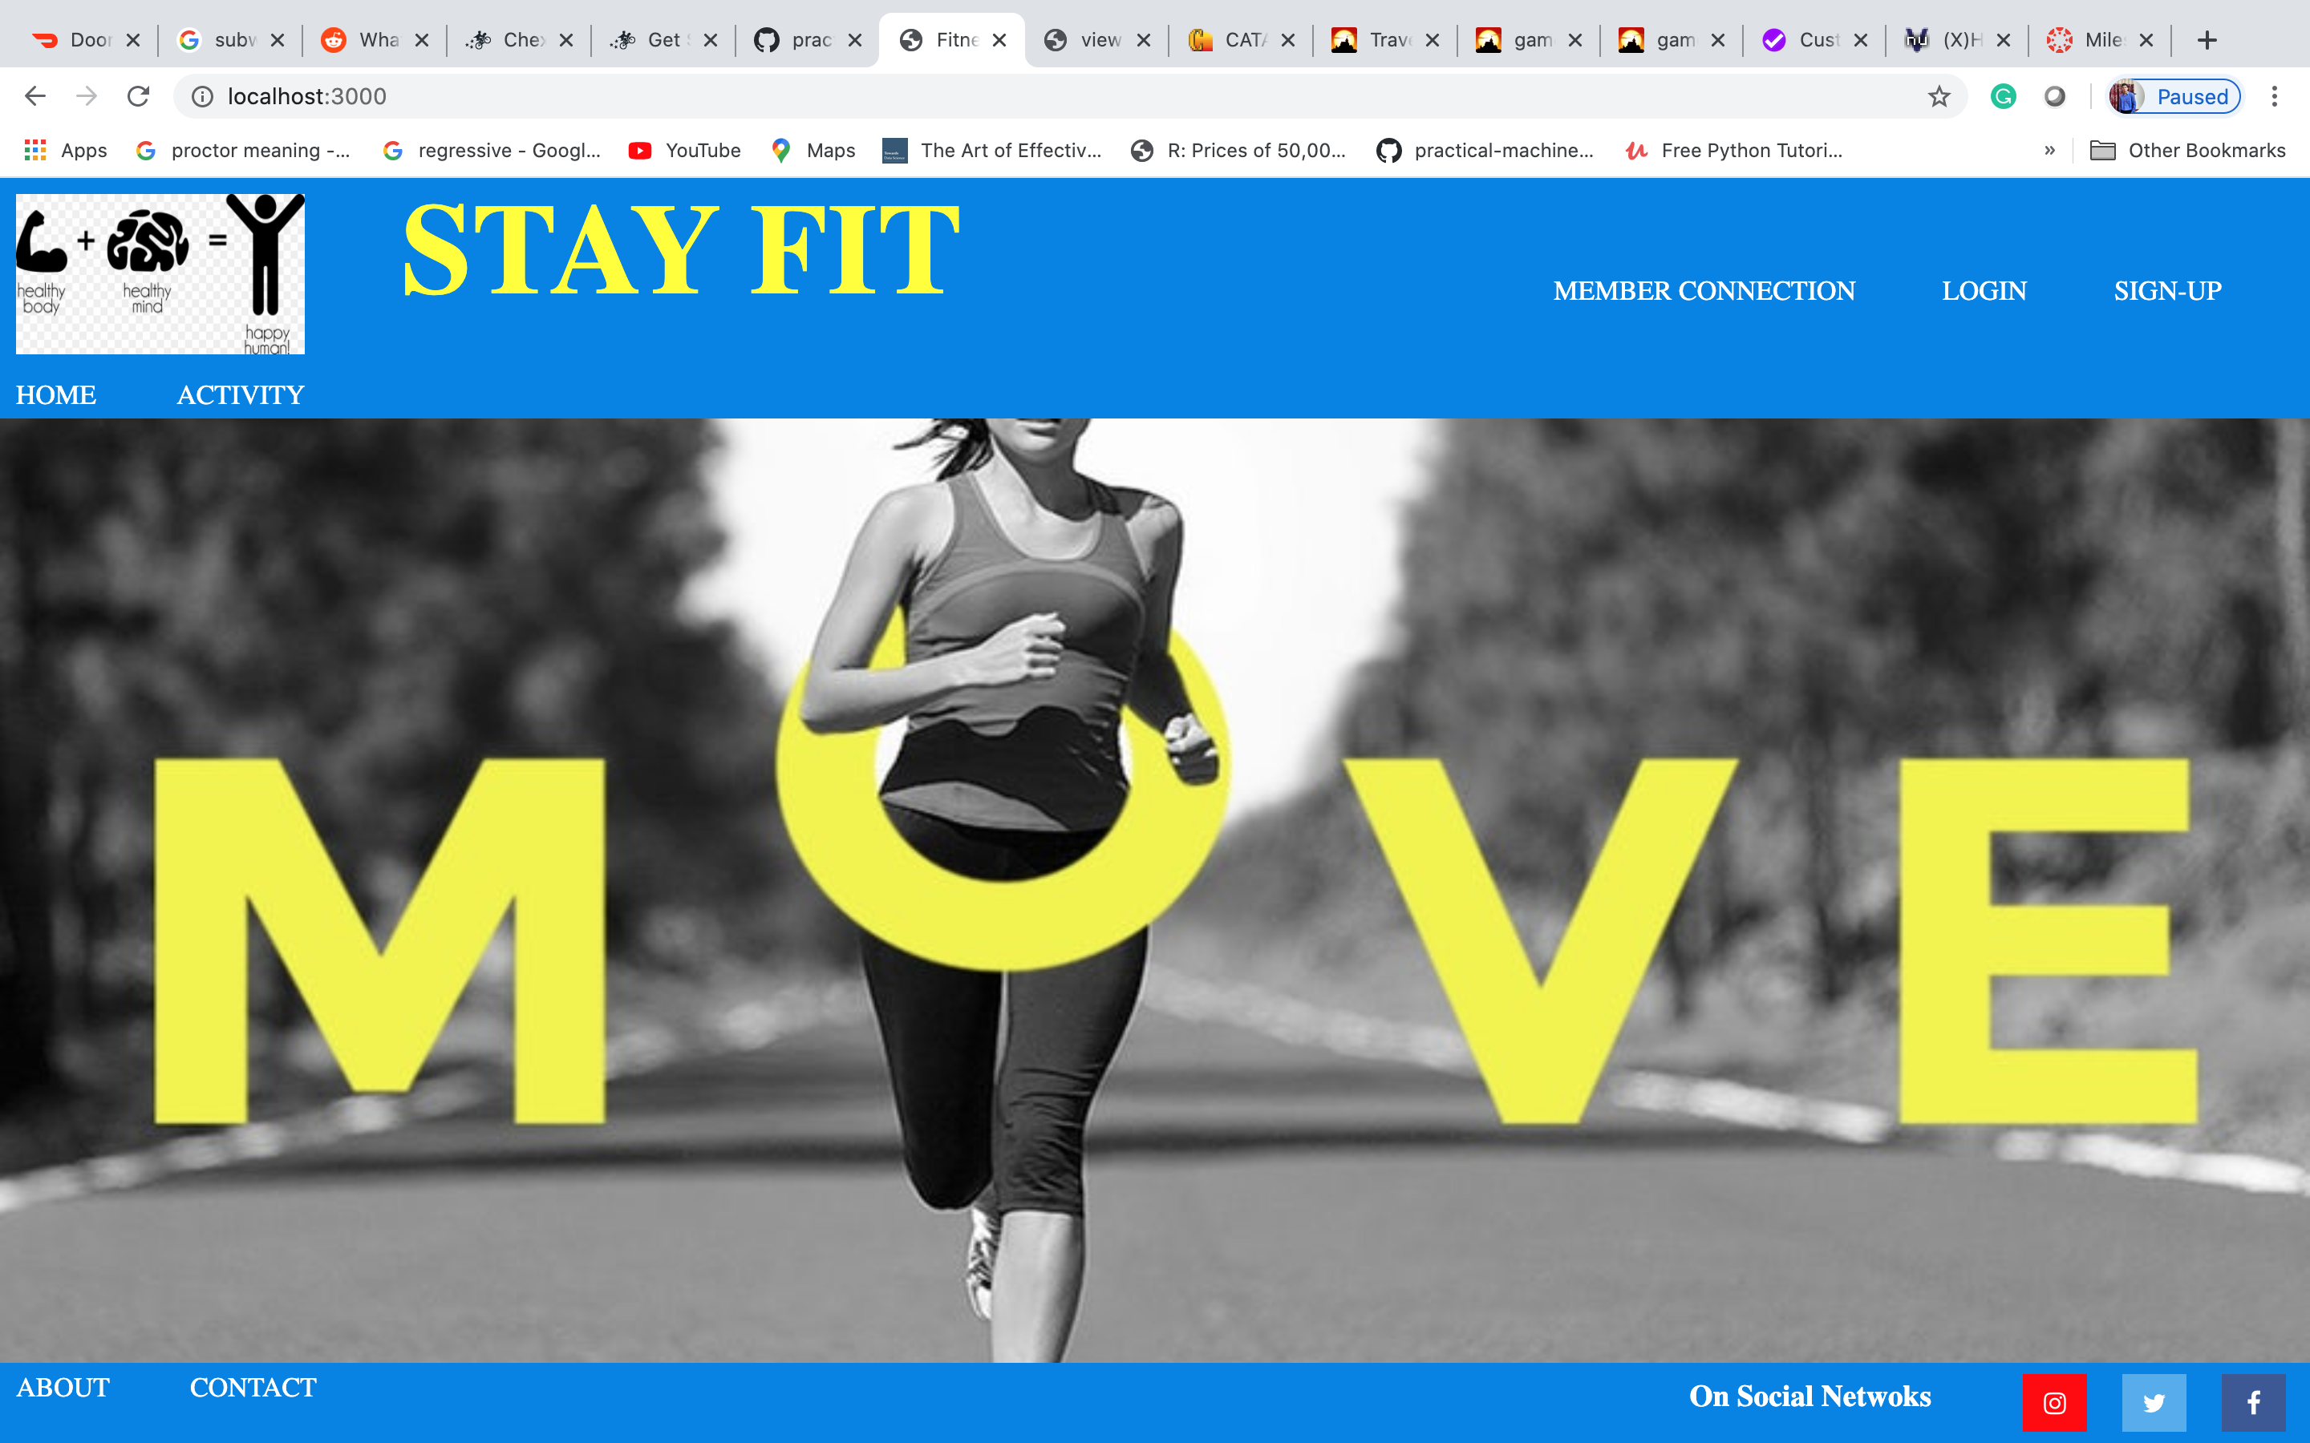

* **About Page**

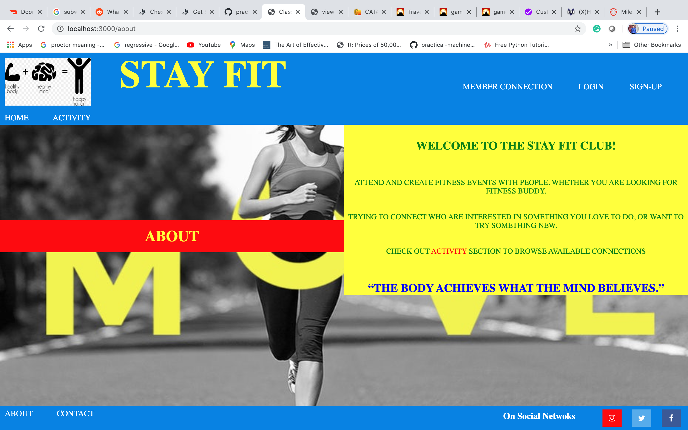

* **Contact Page**

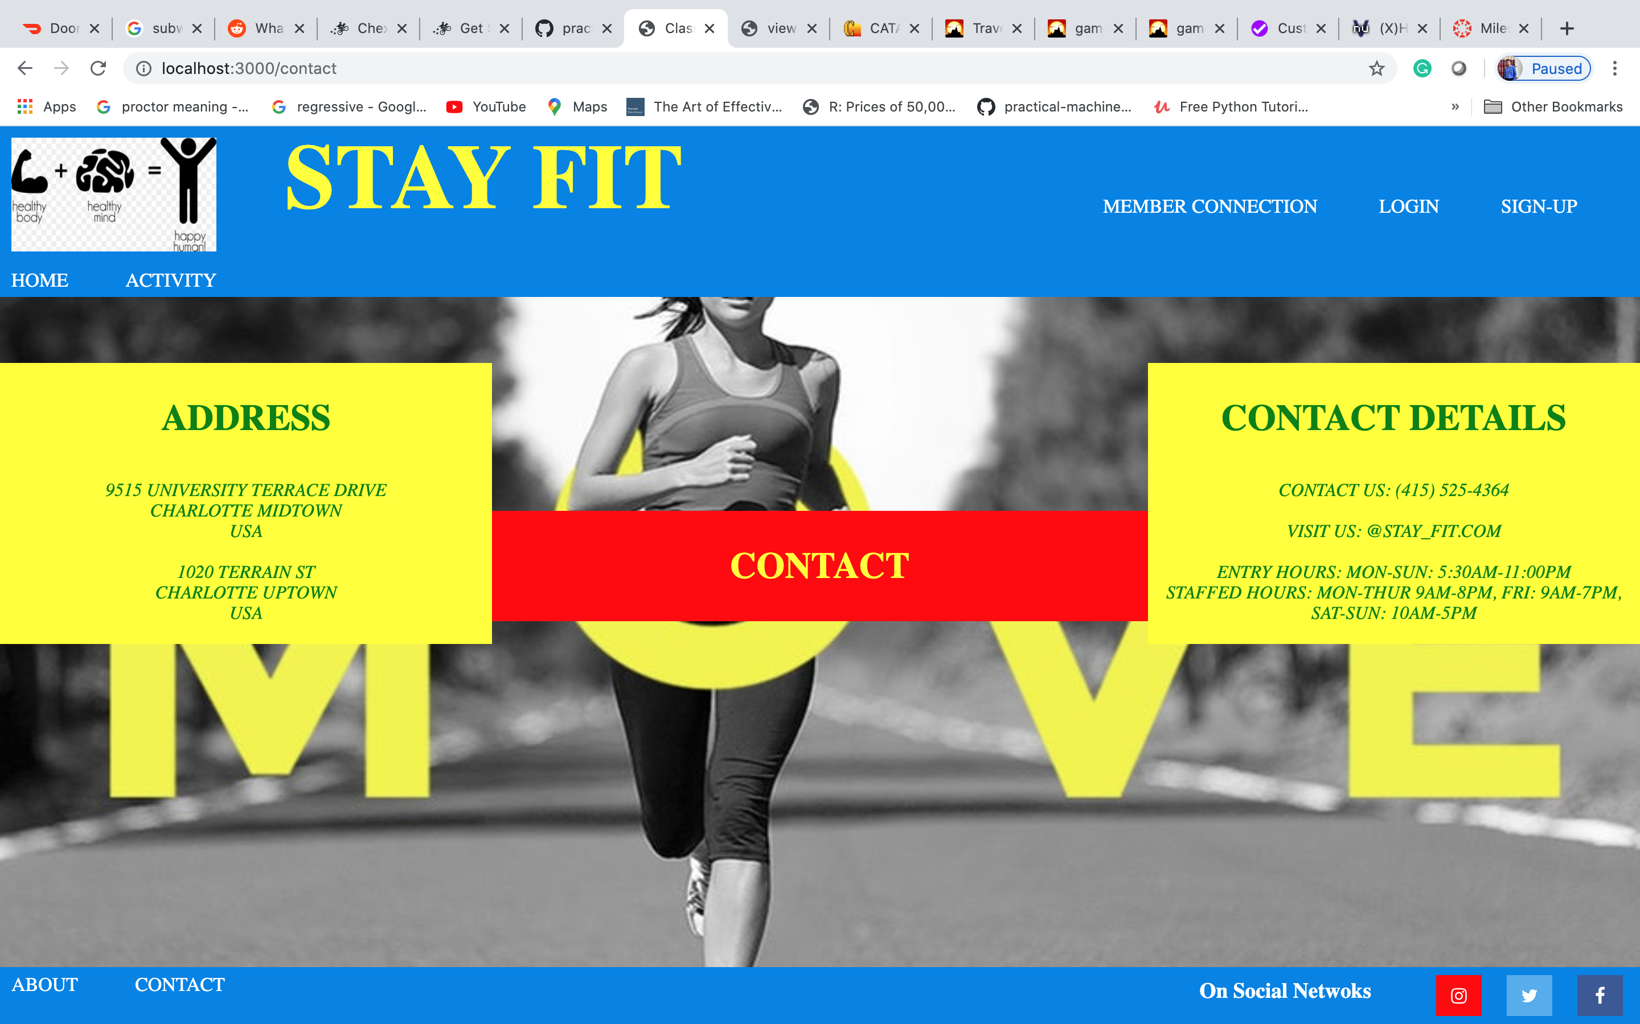

* **Login Page**

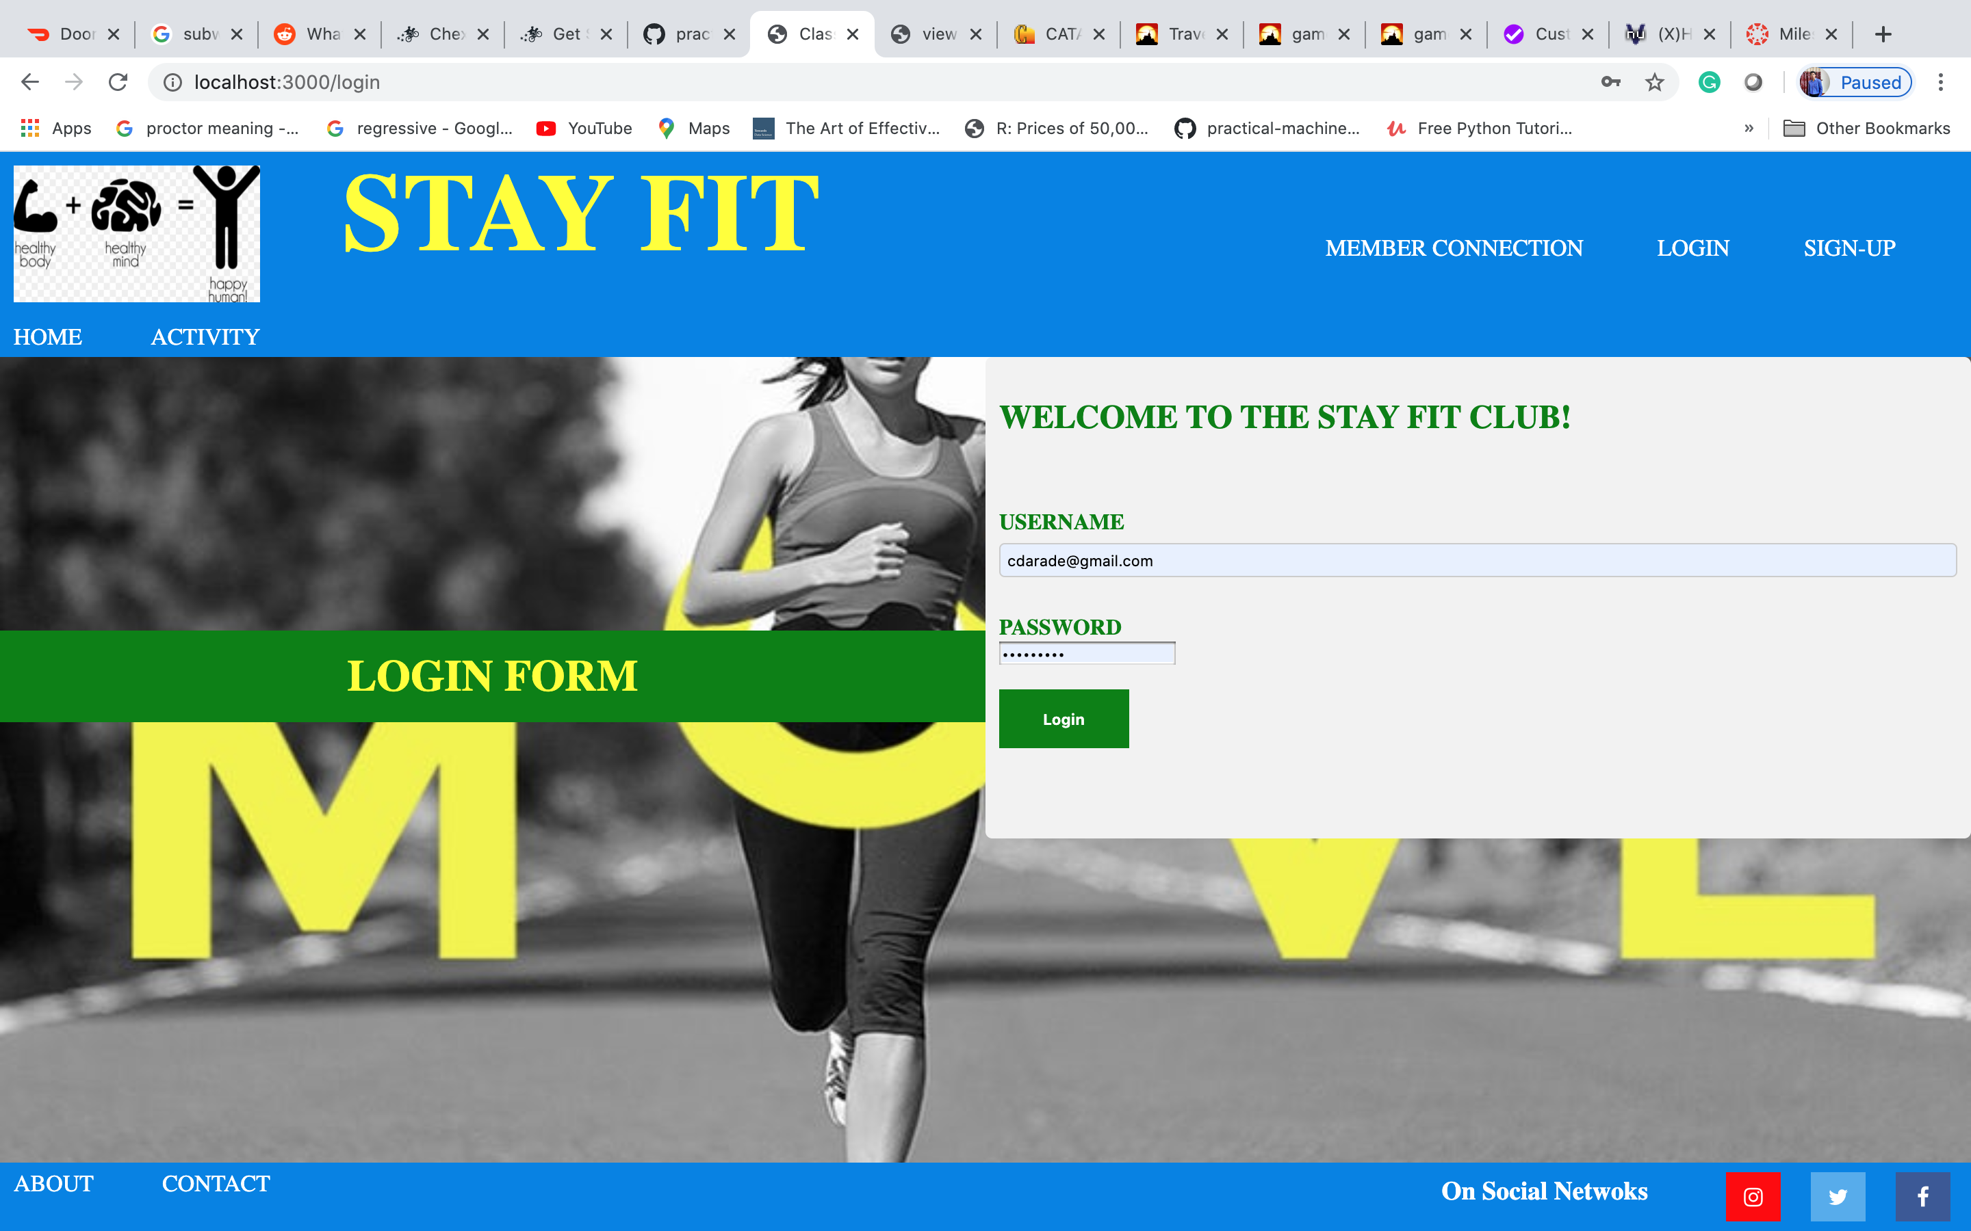

* **Login Page (Failed)**

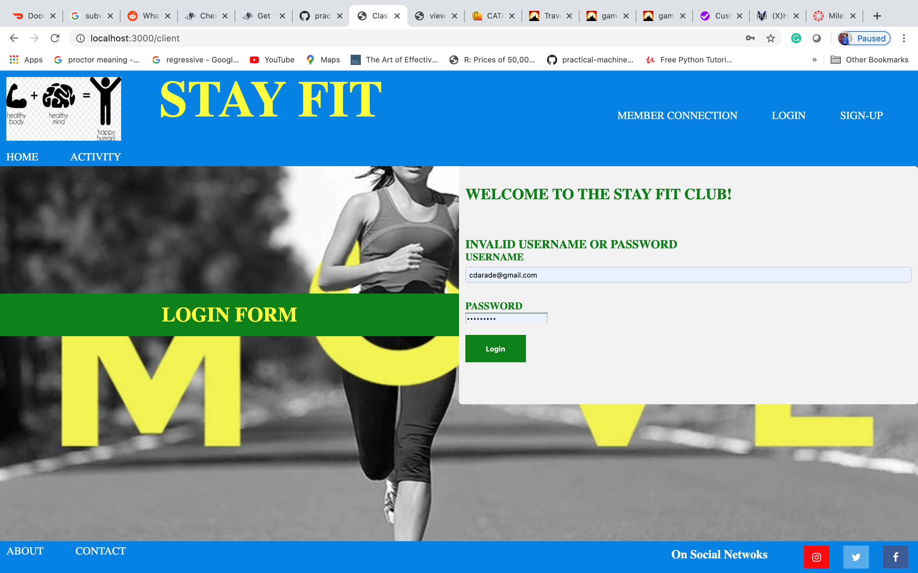

* **Client (Empty Connections) page**

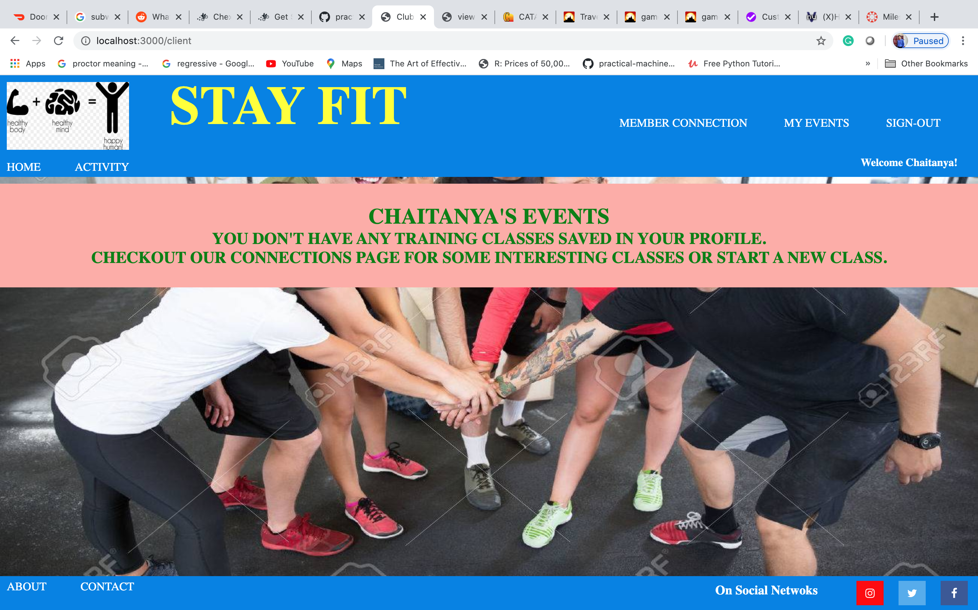

* **Classes (Events) Page**

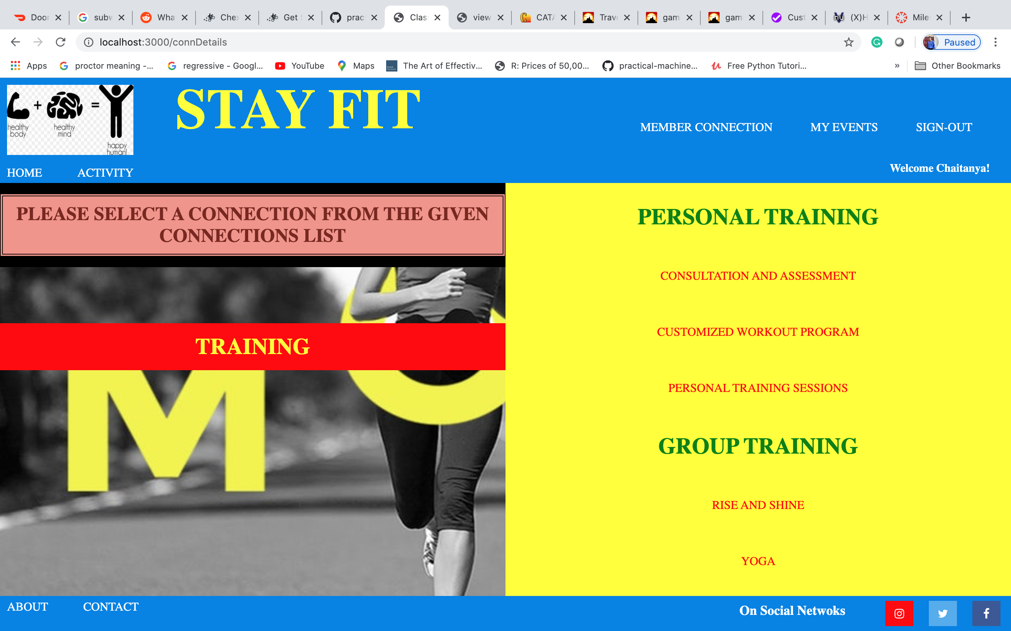

* **Class Detail (Event Detail) Page**

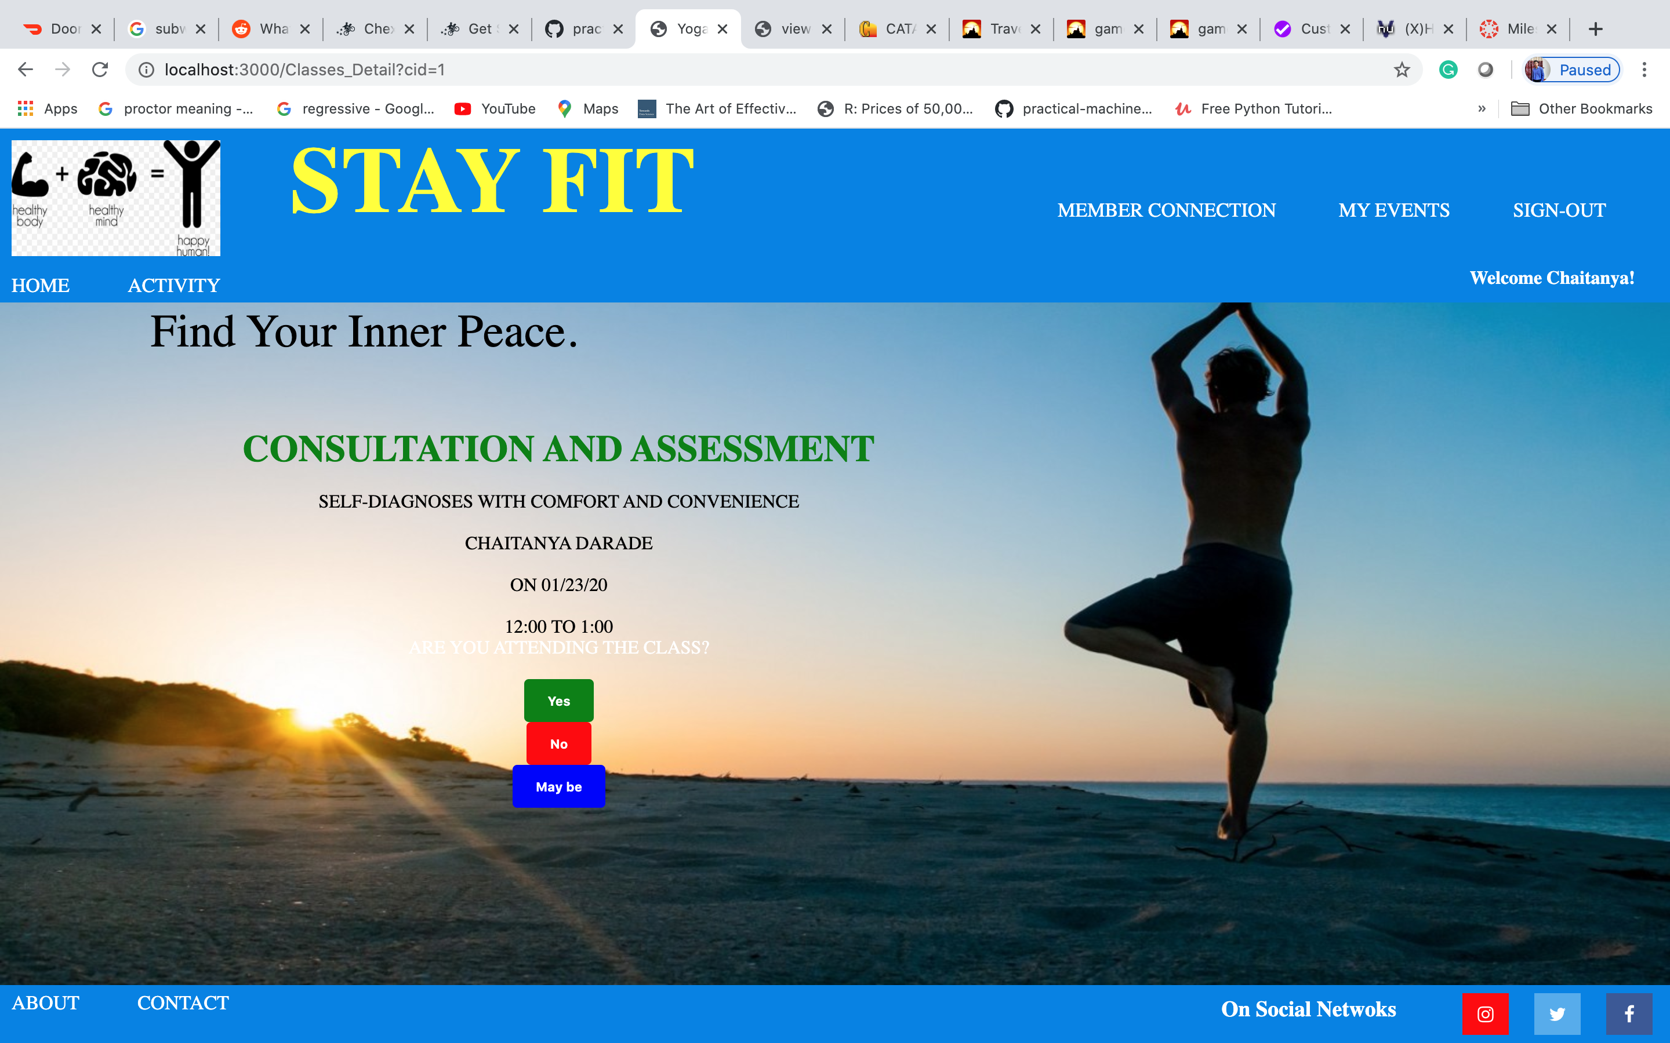

* **Events page (Going - YES)**

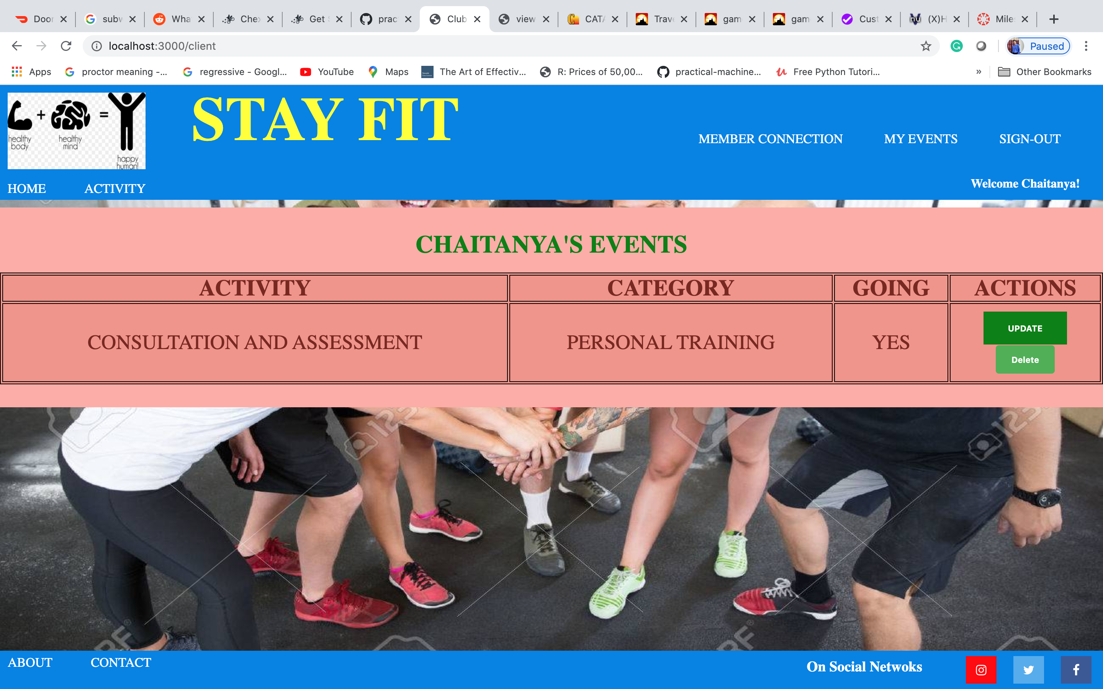

* **Updated Events Page (Going - NO)**

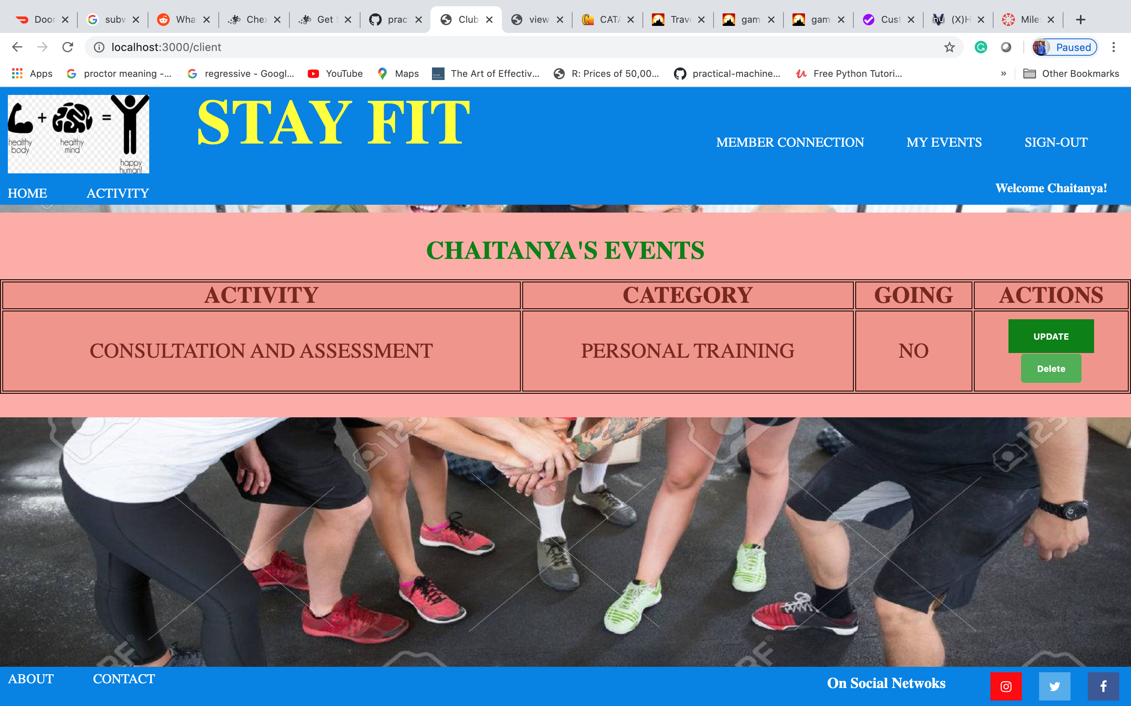

* **Updated Events Page (Added Connection – Yoga)**

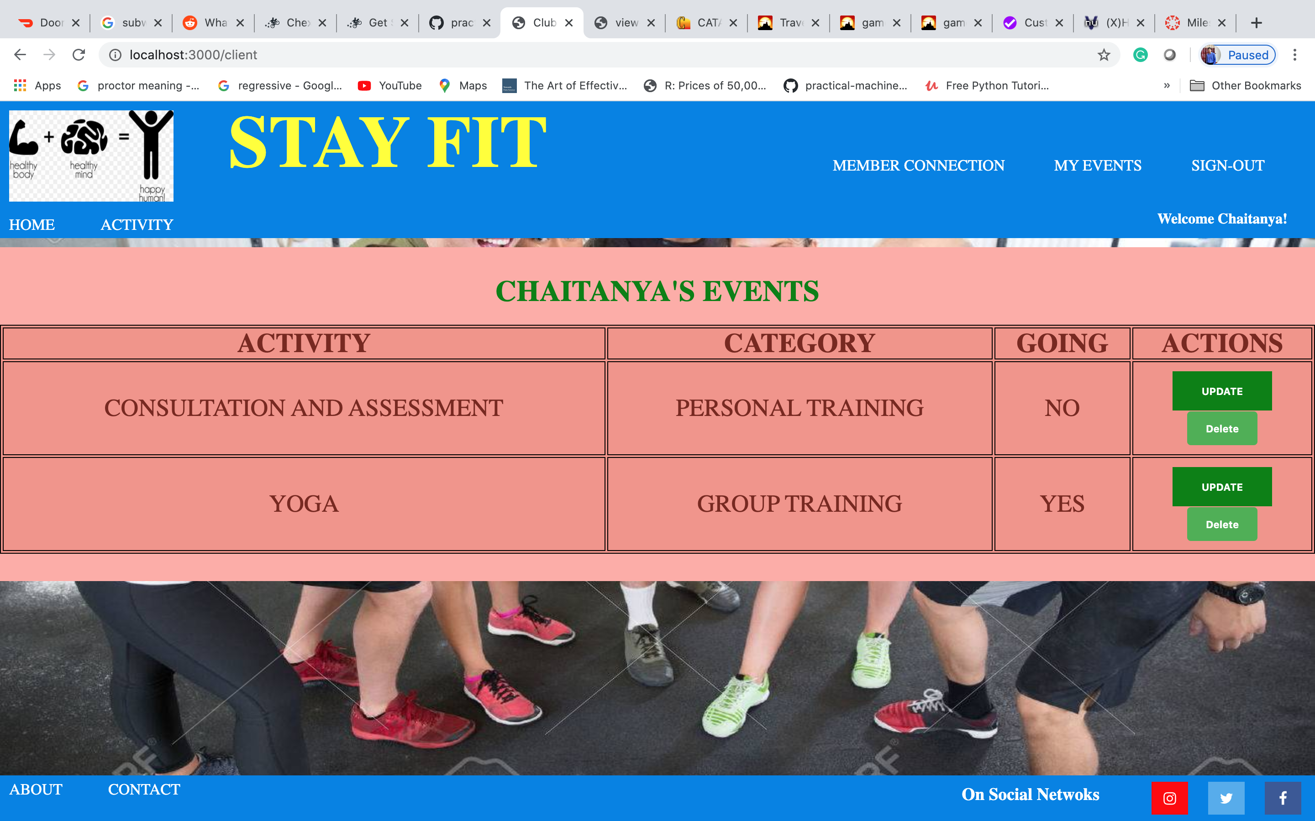

* **Updated Events Page (Deleted Connection – Yoga)**

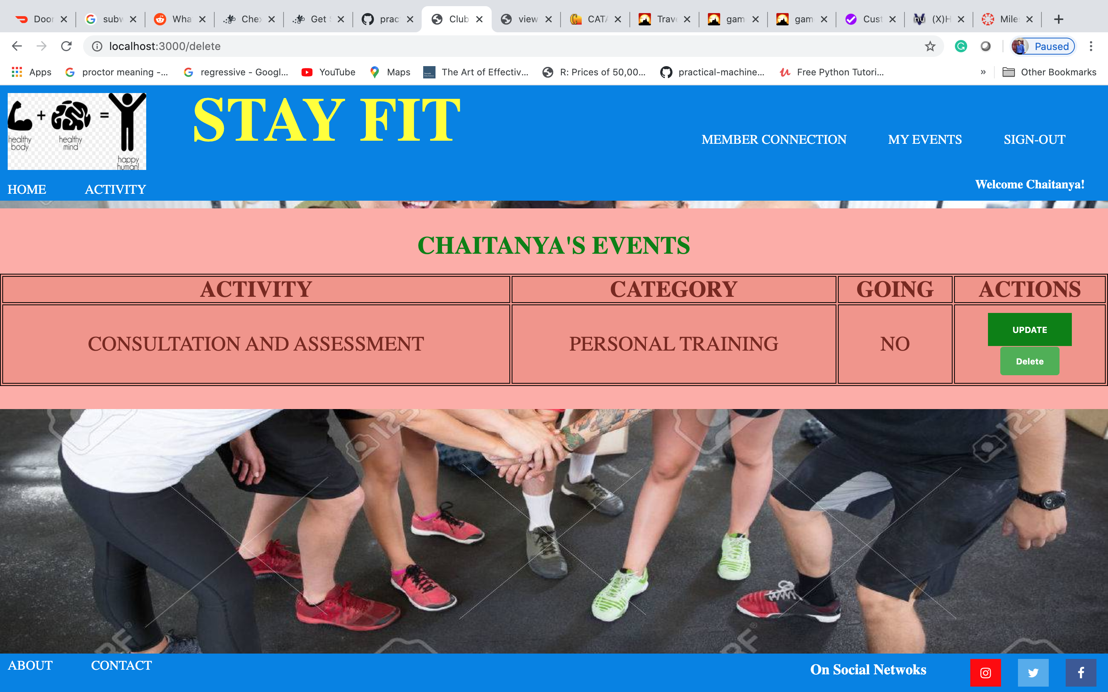

* **Updated Events Page (Deleted All Connections)**

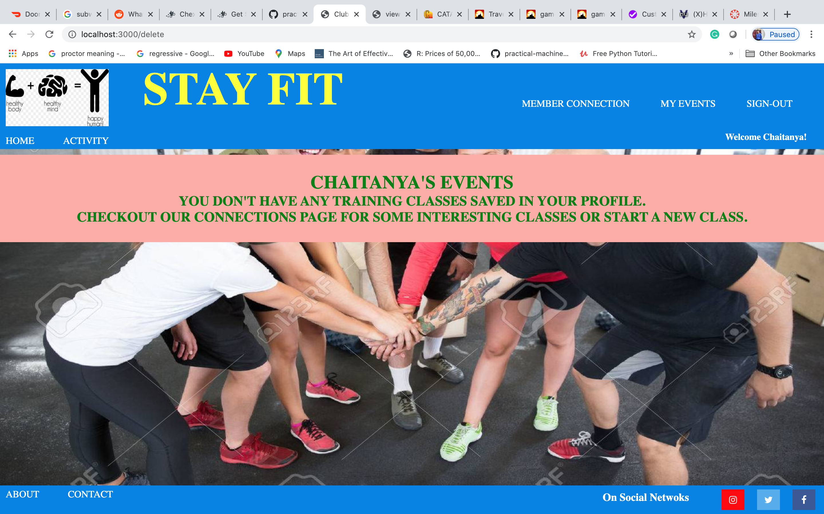

* **New Member Connection**

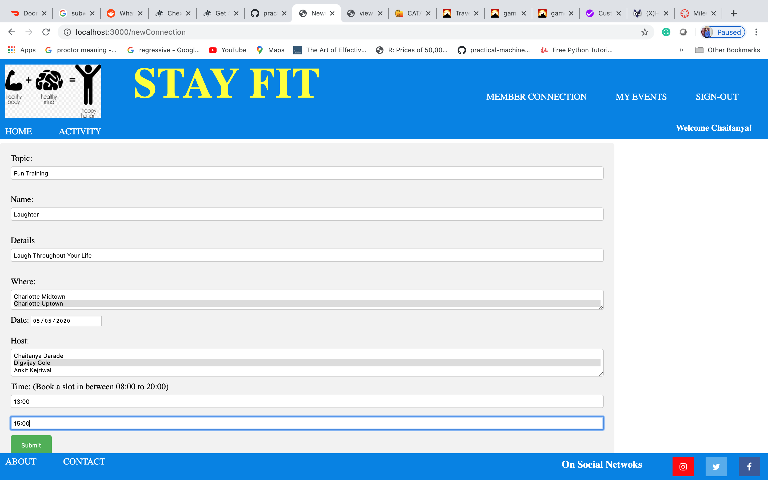

* **New Member Connection Added in Upcoming events**

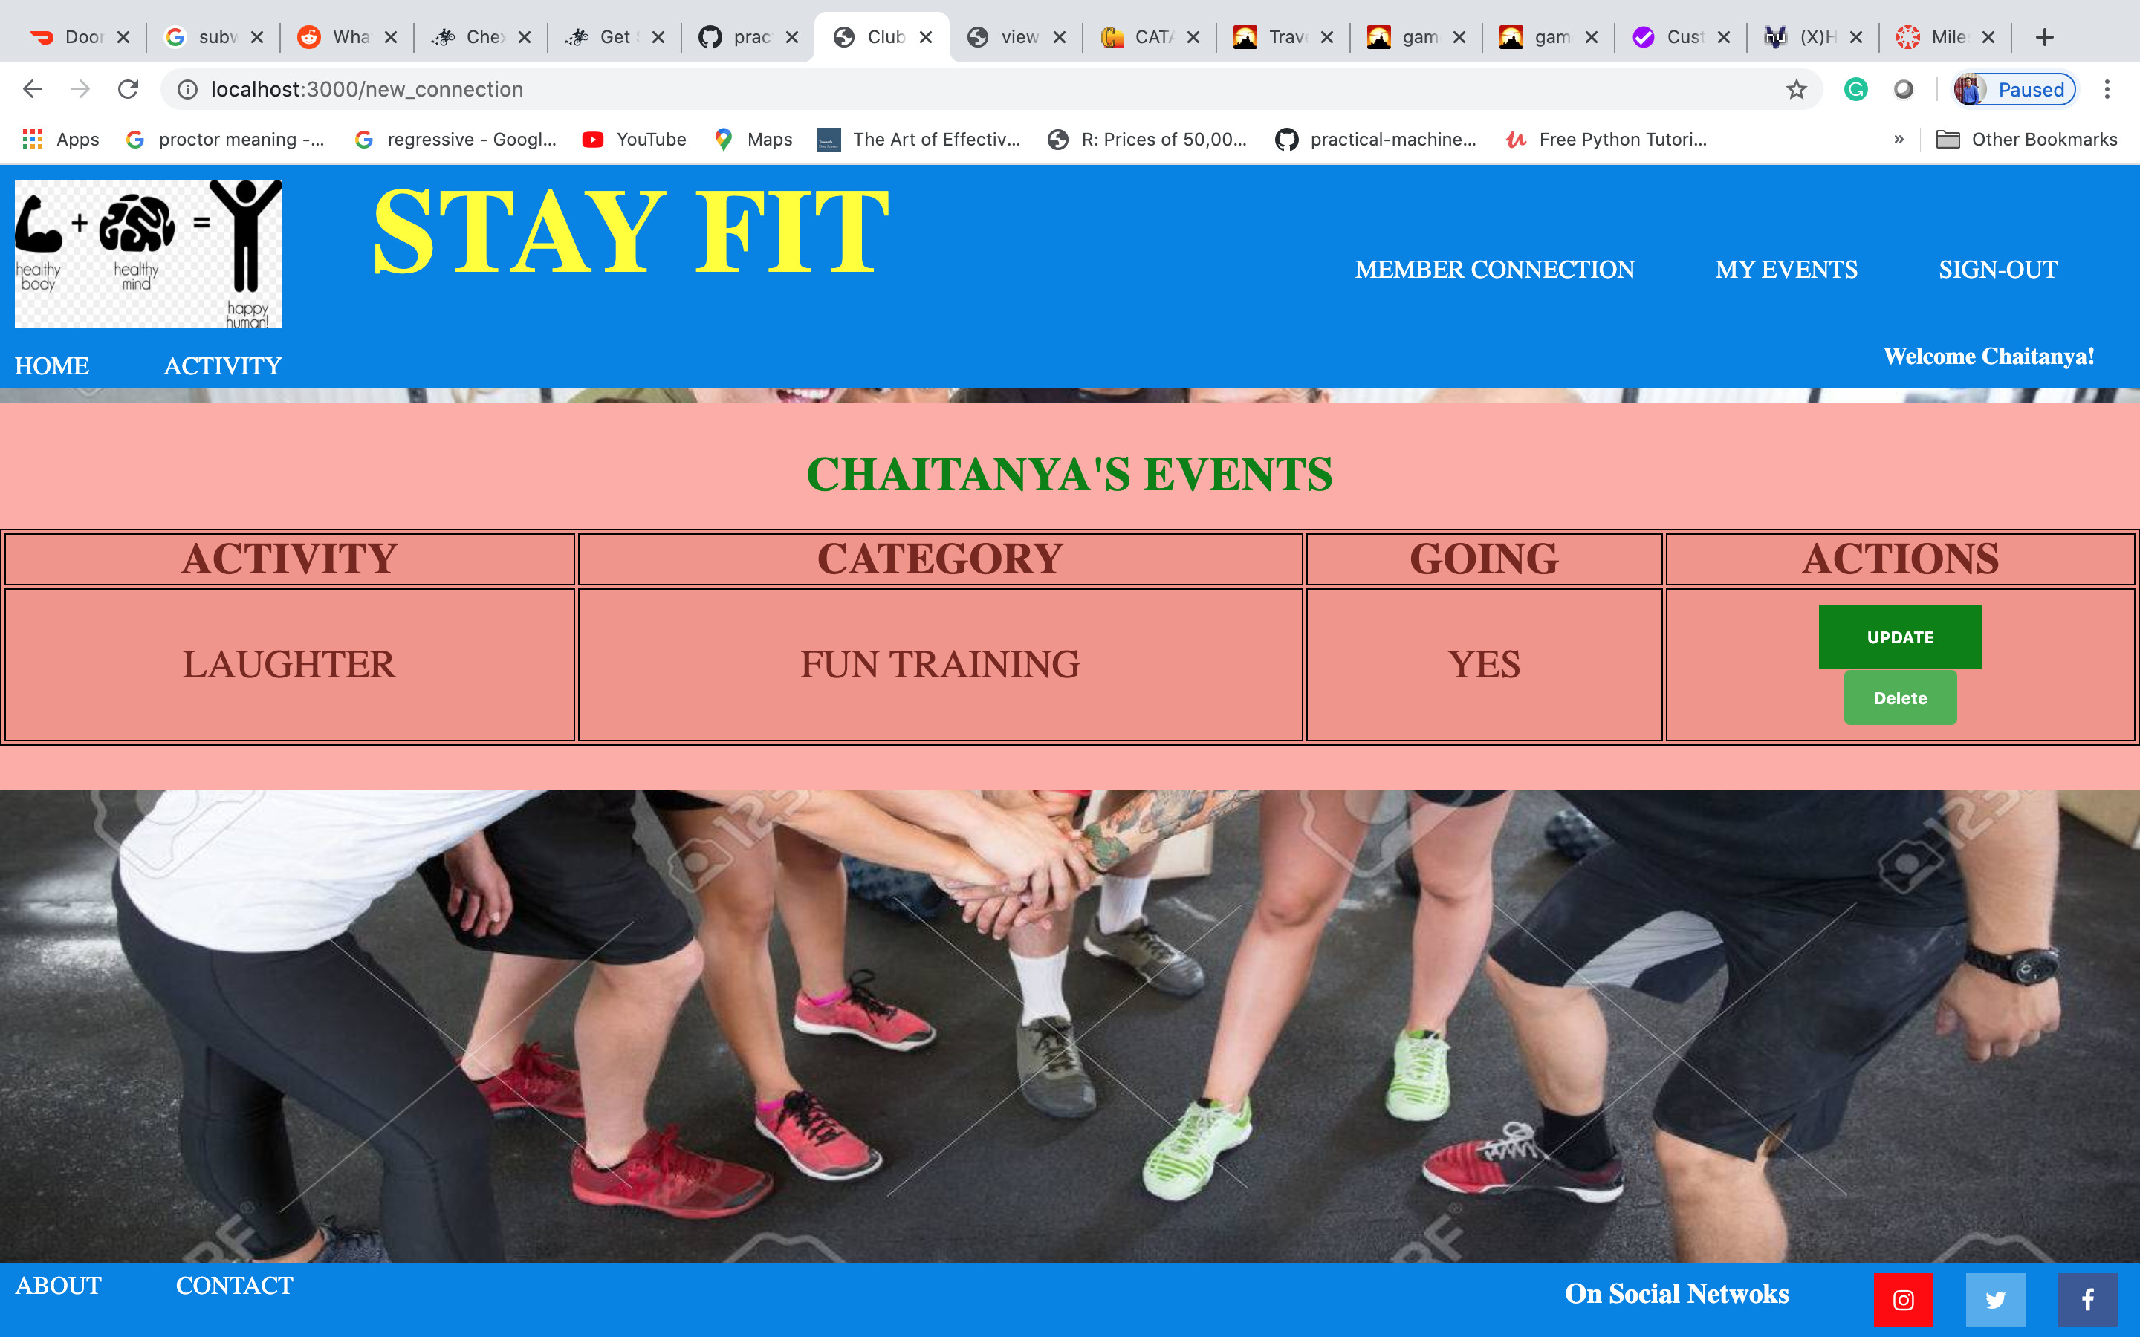

* **New Member Connection Added in events**

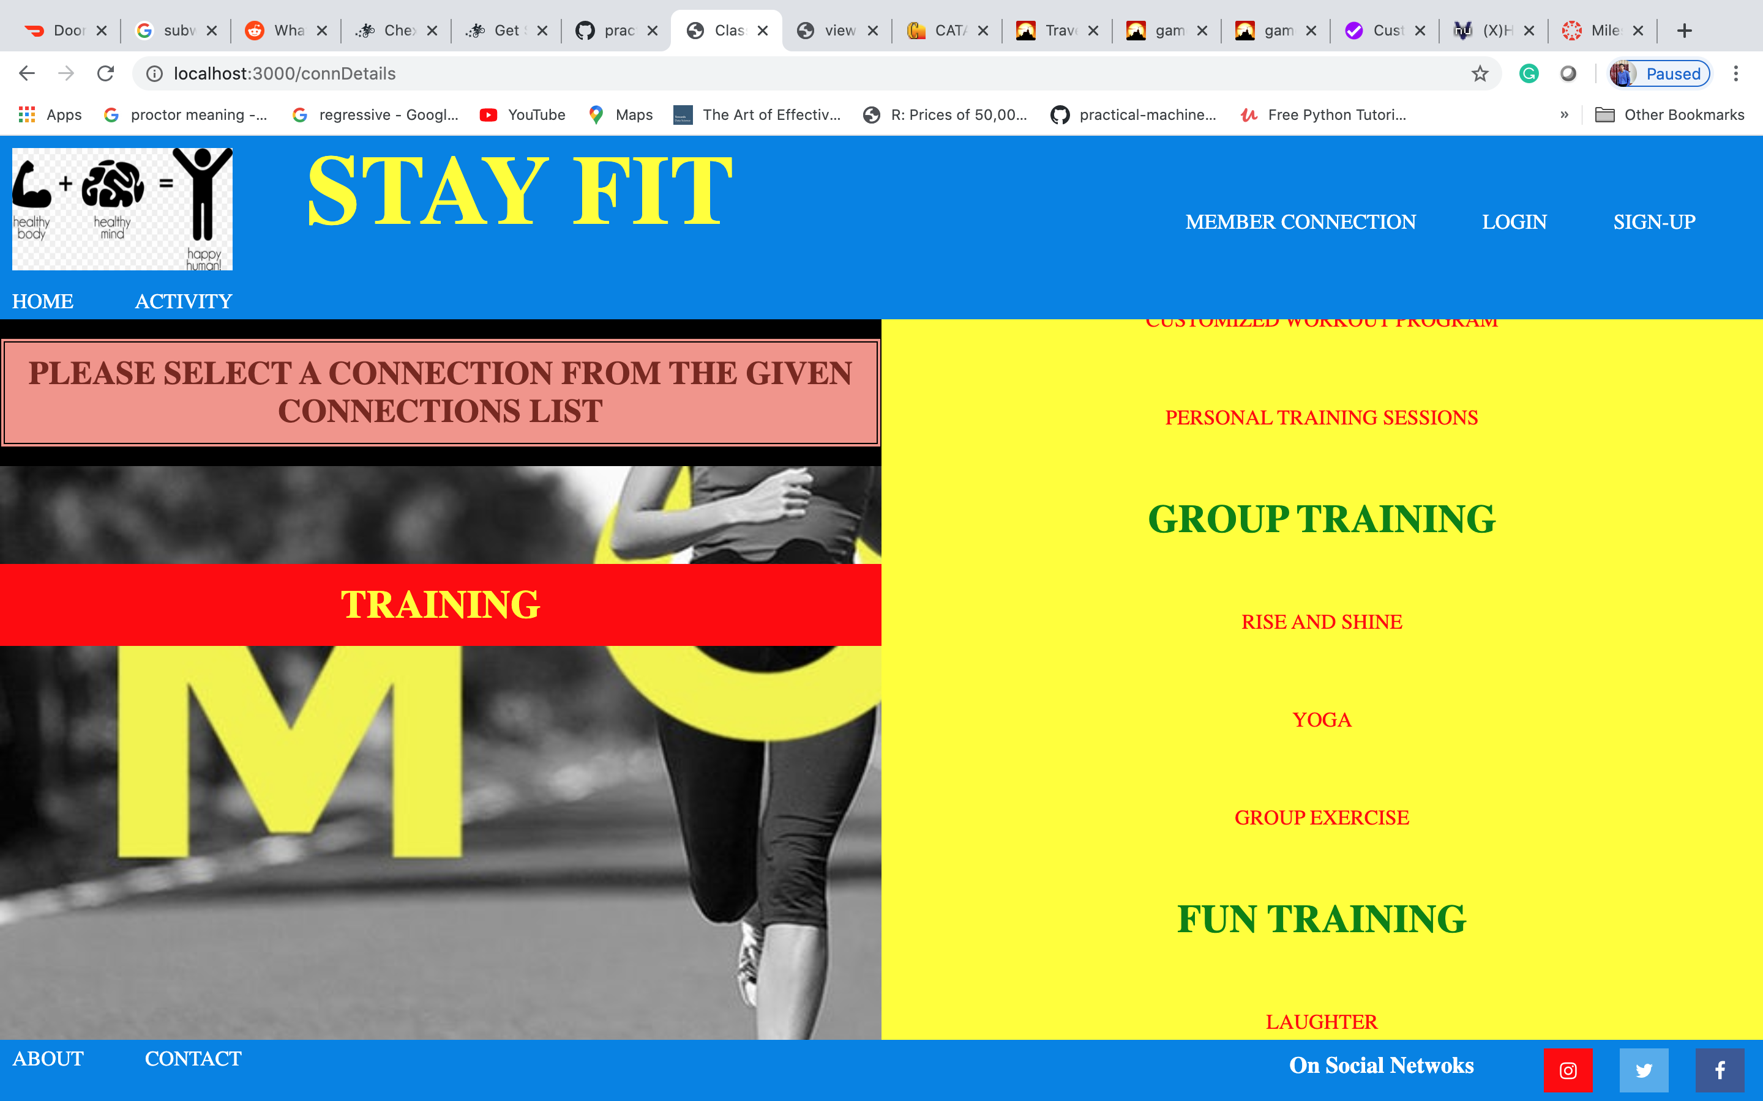

* **New Member Connection Added Details**

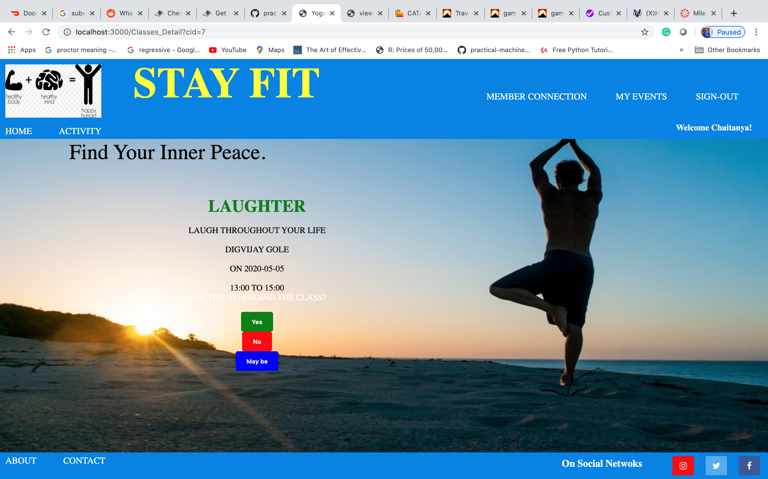

* **Delete newly added member connection as a creator**



* **Deleted newly added member connection from events page**

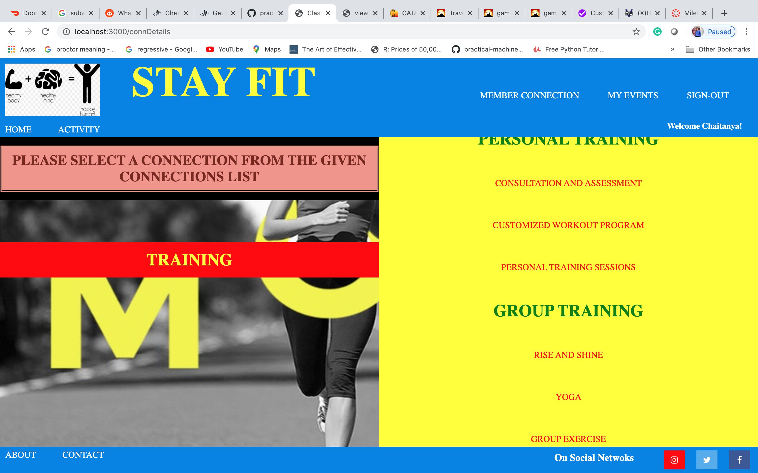

* **New Member Connection (Failed)**

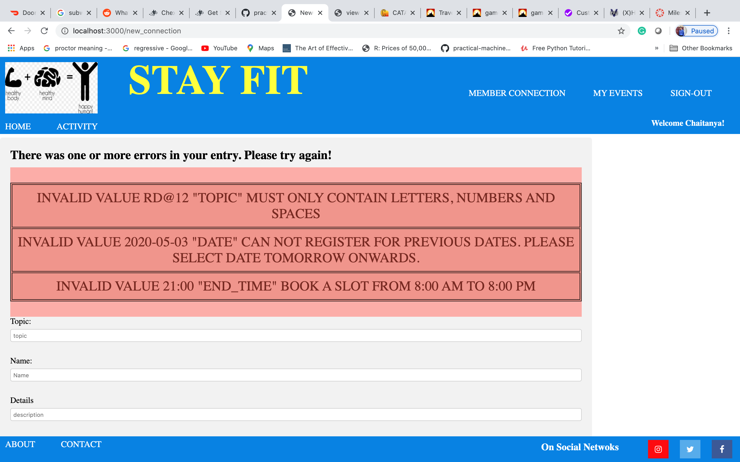

* **Profile Page (After SIGN-OUT)**

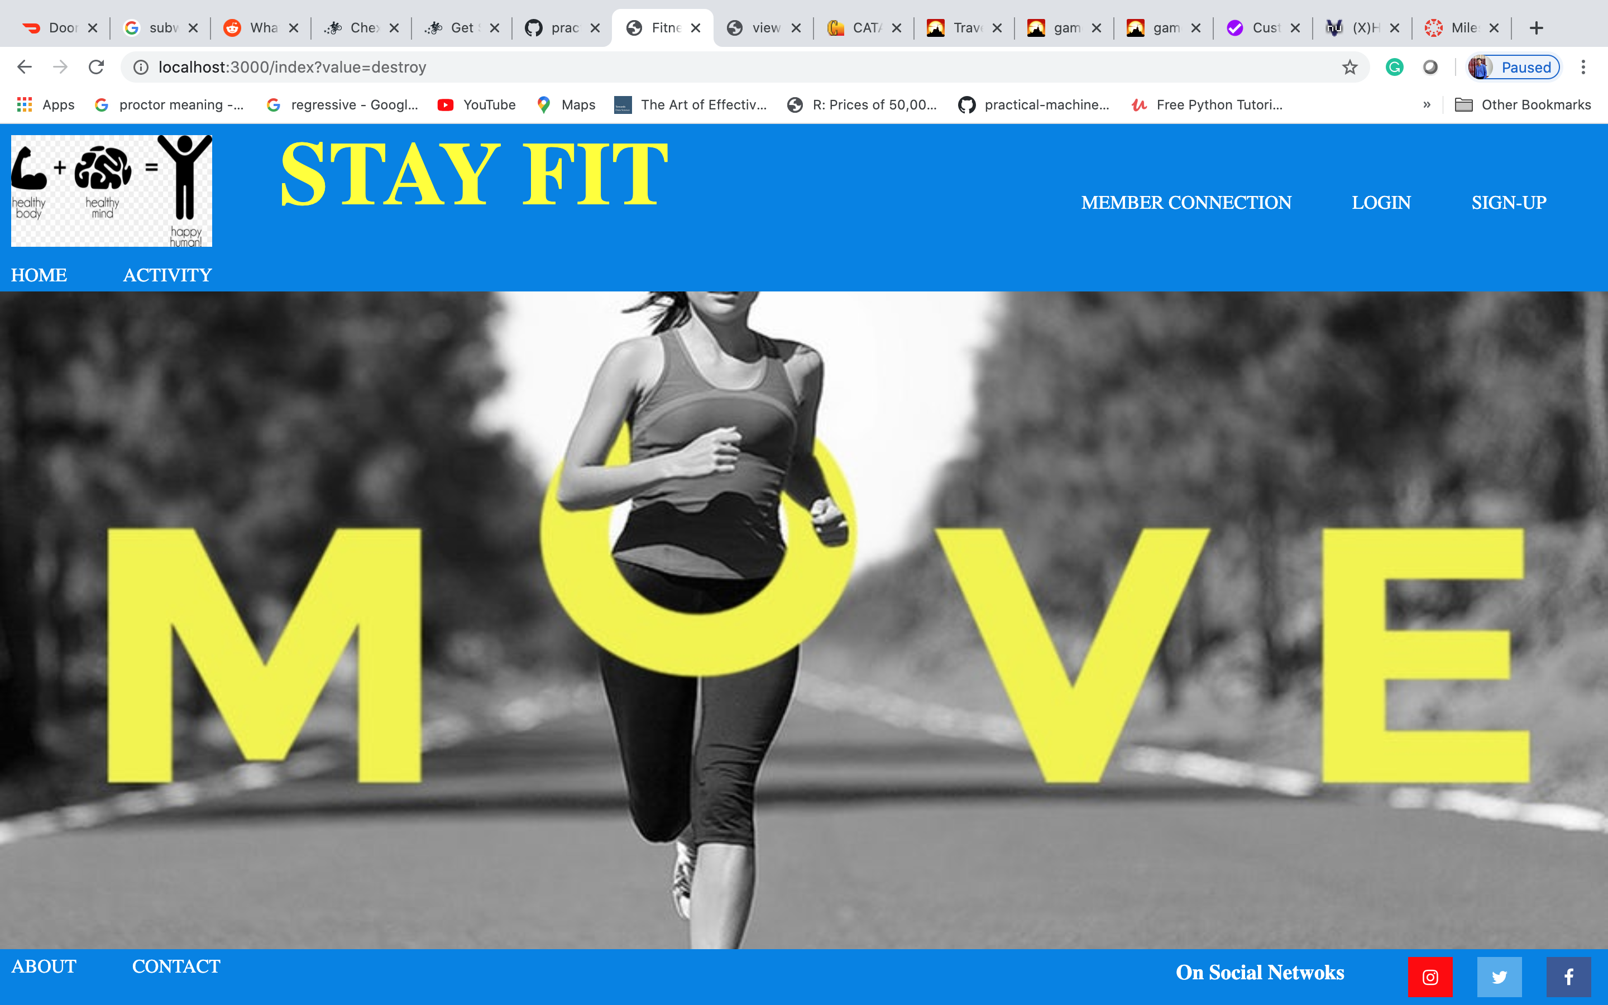

* **Cross Browser Functionality**

1. **Connection added on chrome and login page on safari**

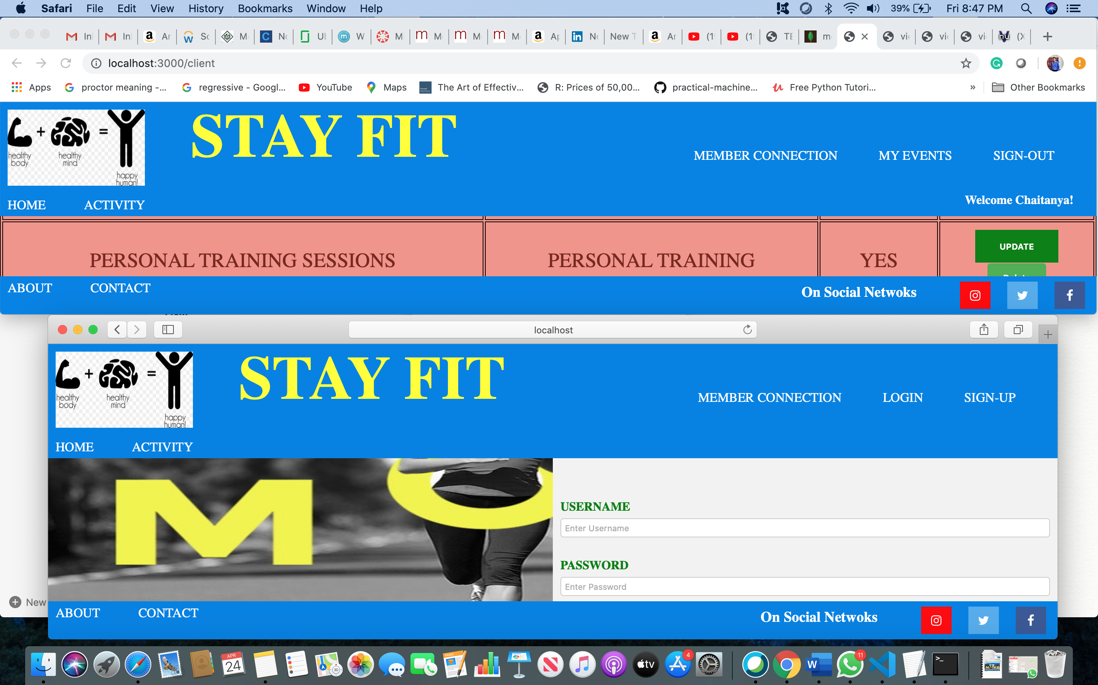

1. **Connection deleted on chrome(deleted from safari as well)**

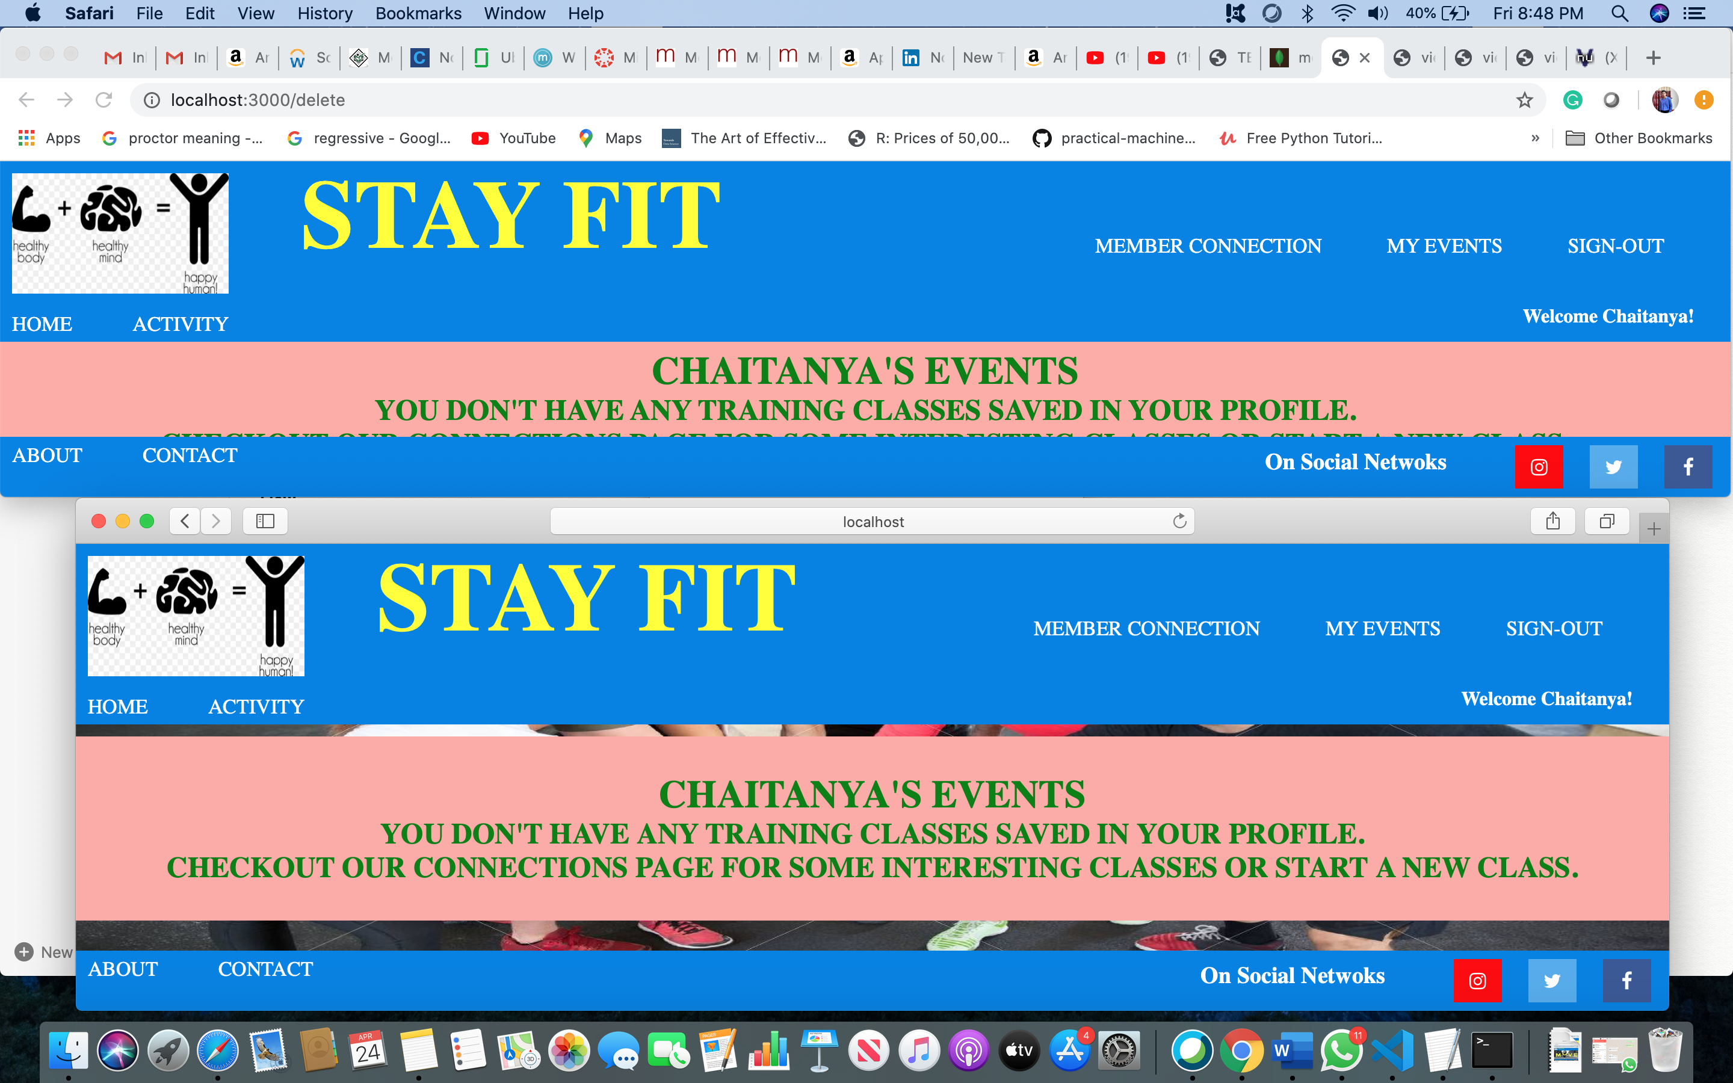

1. **Connection Added on Safari**

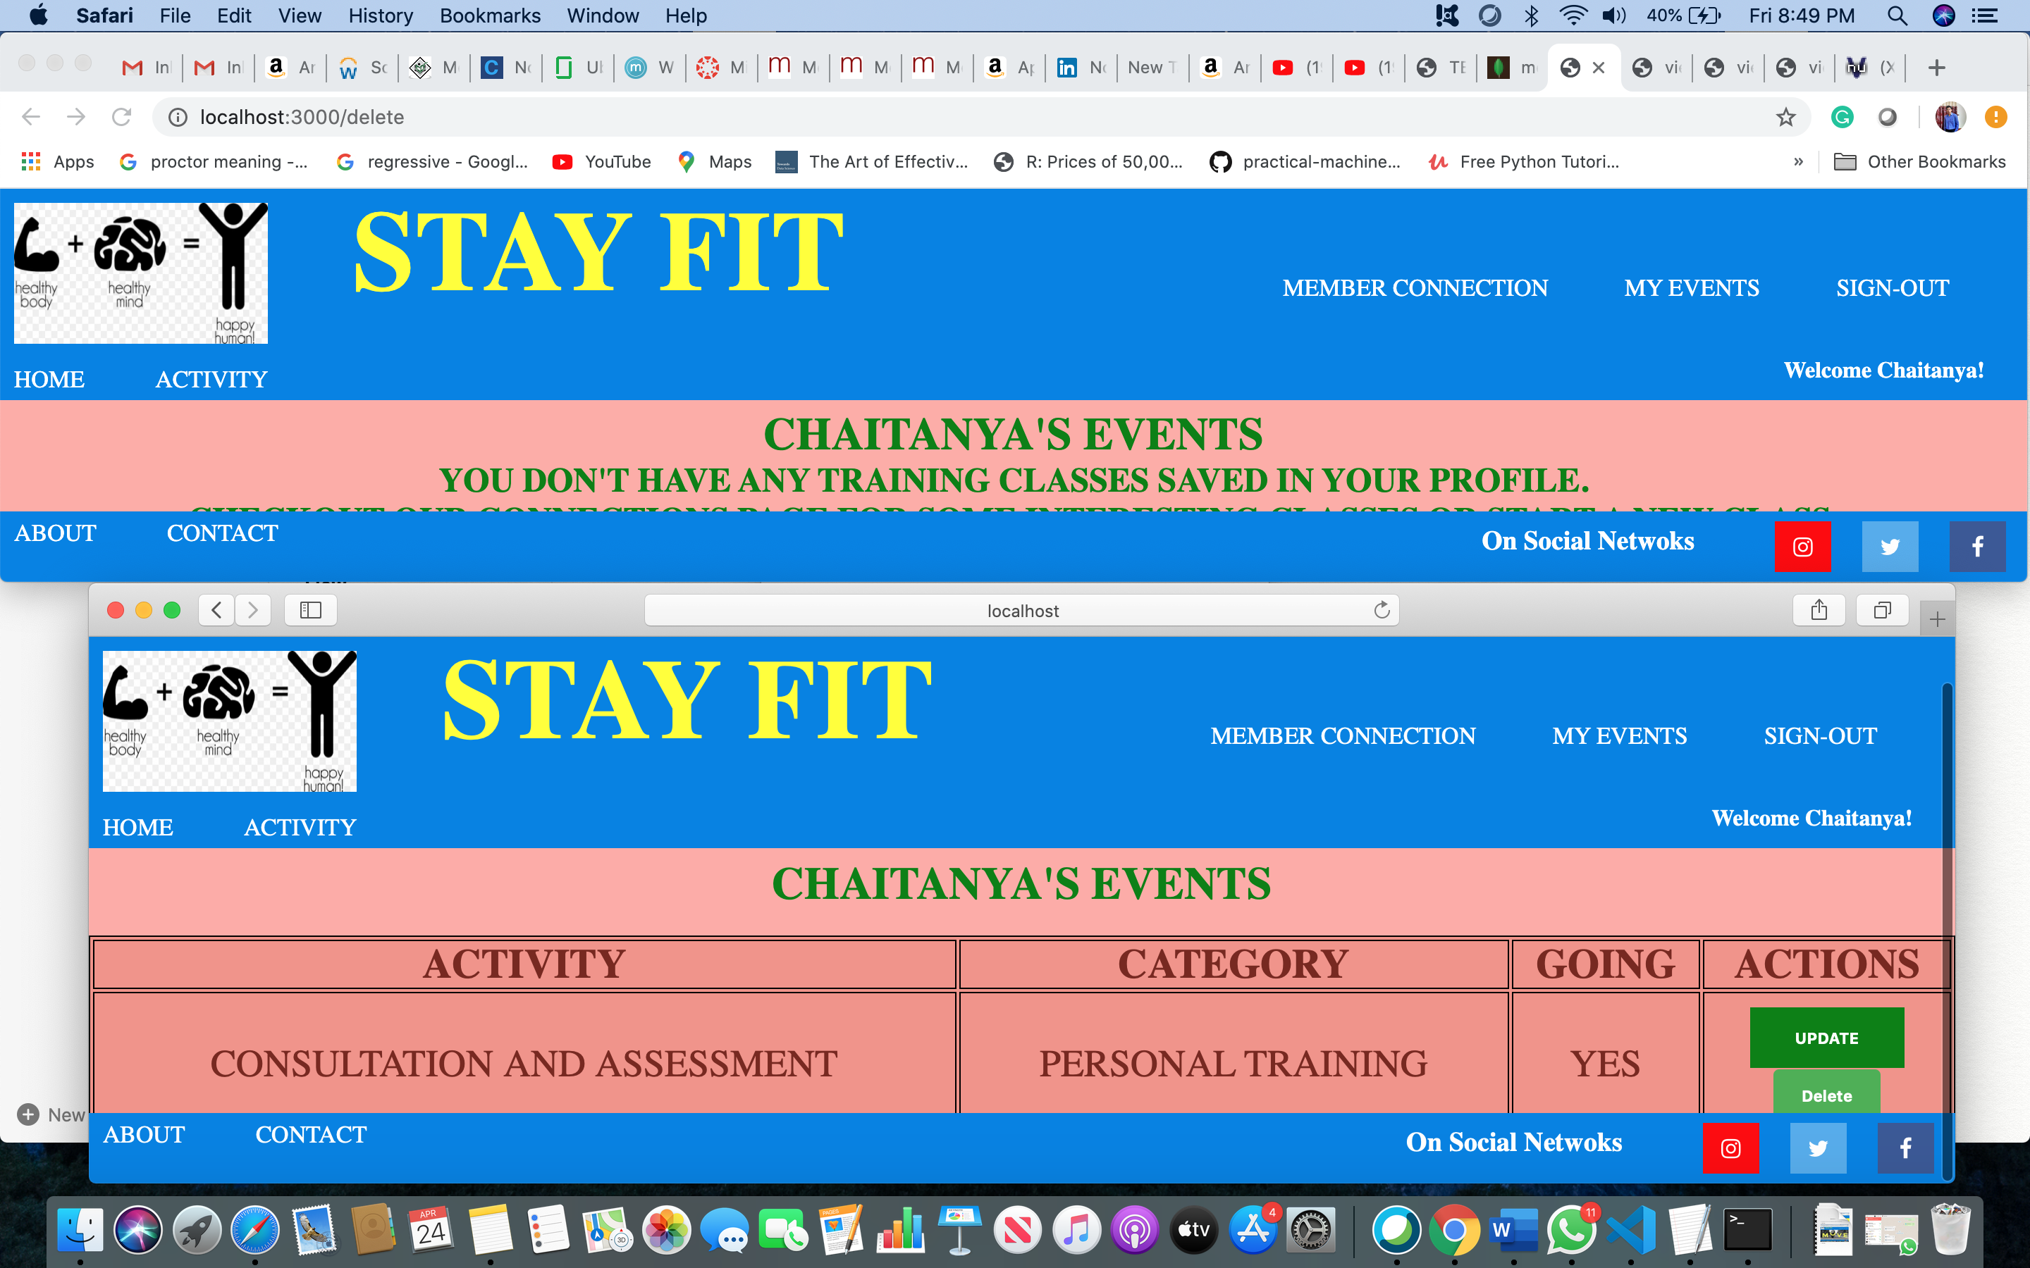

1. **Connection Shown in Chrome as well**

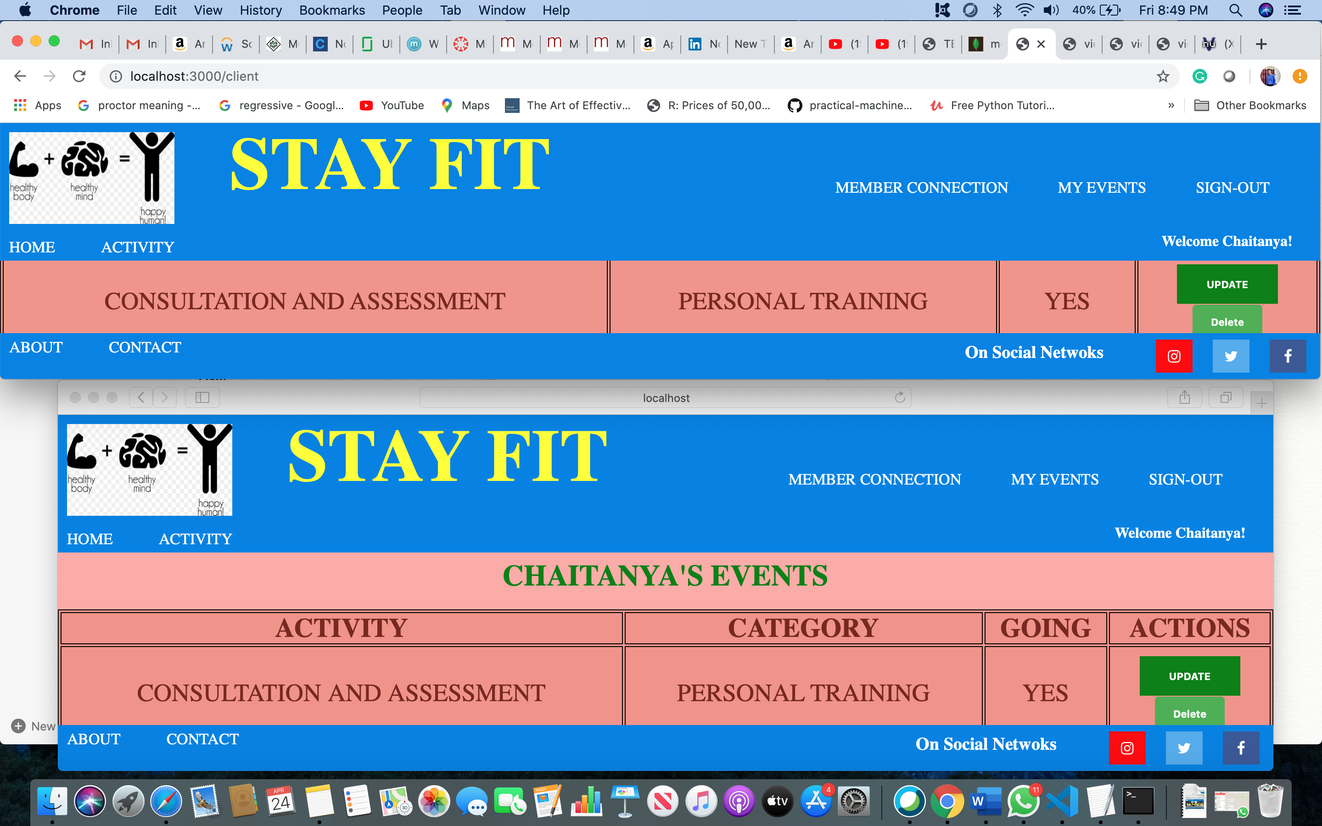

1. **Session Out (Logout) on Safari**

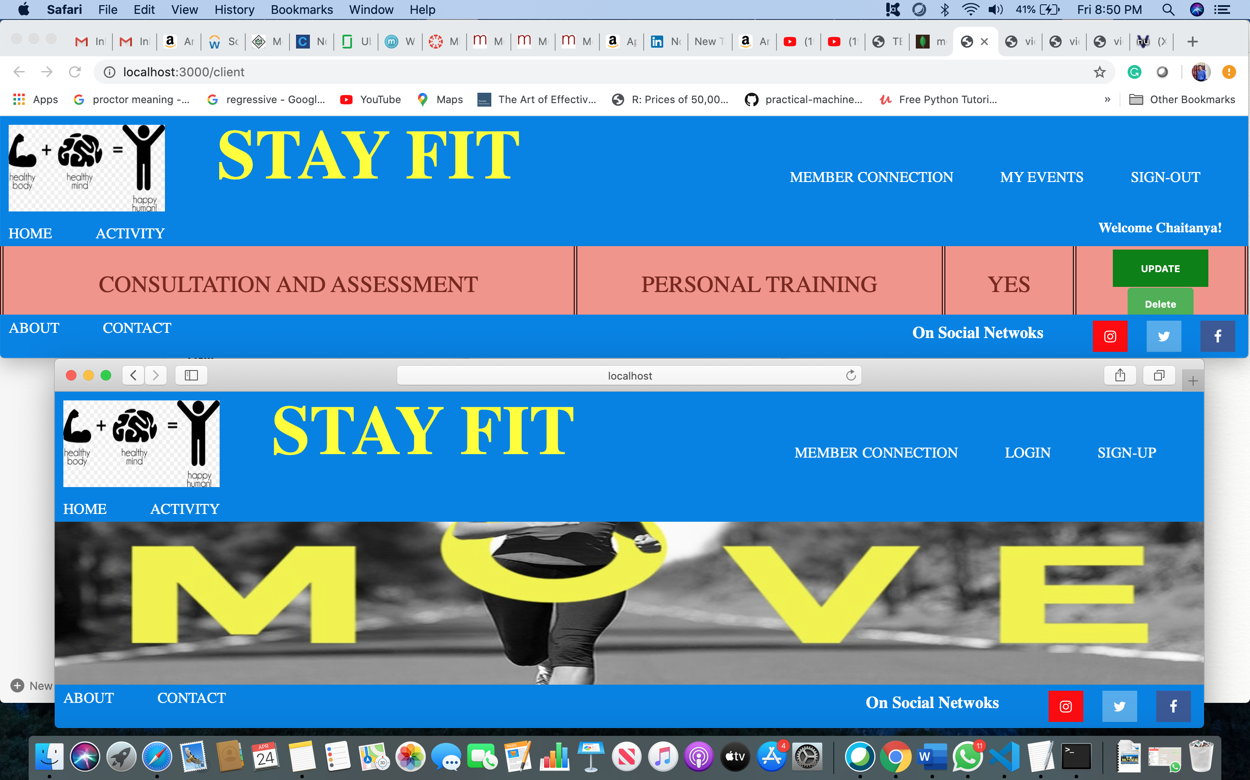

1. Discuss the easy and challenging parts of the milestone. How did you overcome all or some of the challenges?

**Answer:**

Challenging part was handling output encoding for “connections” and “saved_connections” page on cid. Defined functions in connDB.js file, and handled it accordingly.

Second challenge was adding all checks per input field while creating a new connection, especially for time and date input fields.

**Validations added:**

* **Login Validation**

If either Username or password is incorrect, will display error message on Login page.

* **New Member Connection Validation**
  + 1. Topic
       1. Can’t be empty
       2. Must be 3 upto 100 characters
       3. Must only contain letters, numbers and spaces
    2. Name
       1. Can’t be empty
       2. Must be 3 upto 100 characters
       3. Must only contain letters, numbers and spaces
       4. Should not exists as a same Name under same topic
    3. Details
       1. Can’t be empty
       2. Must be 3 upto 300 characters
    4. Date
       1. Can’t be empty
       2. Can’t register for previous dates. Please select date tomorrow onwards.
    5. Start_time
       1. Can’t be empty
       2. Must be of 5 characters within correct format for e.g: 08:00"
       3. End time must be after start time
       4. Book a slot after 8:00 AM to 8:00 PM only
    6. End_time
       1. Can’t be empty
       2. Must be of 5 characters within correct format for e.g: 20:00"
       3. End time must be after start time
       4. Book a slot after 8:00 AM to 8:00 PM only